

Submitted by:
M Lakshmi
24MSRDF016
MSc DFIS
School of science

Submitted to
Mr. Vishnu Venkatesh
Assistant professor
Jain school of sciences

Log Tampering Attack vs Secure Logging Defense Simulator

1. Abstract:
This project presents a simulation of a log tampering attack and its corresponding defense mechanism using secure logging techniques. Logs play a critical role in cybersecurity by recording system activities and enabling forensic investigations. However, attackers often attempt to alter these logs to conceal their malicious actions.
This system demonstrates how cryptographic hashing (SHA-256) can be used to ensure log integrity and detect unauthorized modifications through a user-friendly graphical interface.

2. Introduction:

In modern cybersecurity infrastructure, logs act as the backbone for monitoring and auditing system activities. Security analysts rely on logs to detect anomalies, trace attacks, and perform digital forensics. However, attackers frequently target logs to erase evidence of compromise.
This project focuses on simulating such an attack scenario and implementing a defense mechanism that ensures the integrity of logs using cryptographic techniques.

3. Objectives:
• To simulate log tampering attacks
• To understand the importance of log integrity
• To implement a hashing-based detection mechanism
• To design a GUI-based simulation system
• To demonstrate attack-defense workflow in a cyber range environment

4. Literature Background:
Log tampering is a common post-exploitation technique used by attackers. In real-world environments, systems like SIEM (Security Information and Event Management) rely heavily on log data.
Cryptographic hash functions such as SHA-256 are widely used for ensuring data integrity. They produce a fixed-length output that changes significantly even with a minor change in input, making them highly effective for tamper detection.

5. System Design:

The system is designed with three primary modules:
1. Log Generation Module – Creates sample logs representing system activity
2. Attack Module – Simulates tampering by modifying logs
3. Detection Module – Verifies integrity using hash comparison
These modules are integrated into a GUI for user interaction.

6. Methodology:
The methodology follows a simple attack-defense approach:
Step 1: Generate logs and compute their hash
Step 2: Store the hash securely
Step 3: Simulate an attack by modifying logs
Step 4: Recompute hash and compare with original
Step 5: Display result based on comparison
This approach mimics real-world integrity verification systems.

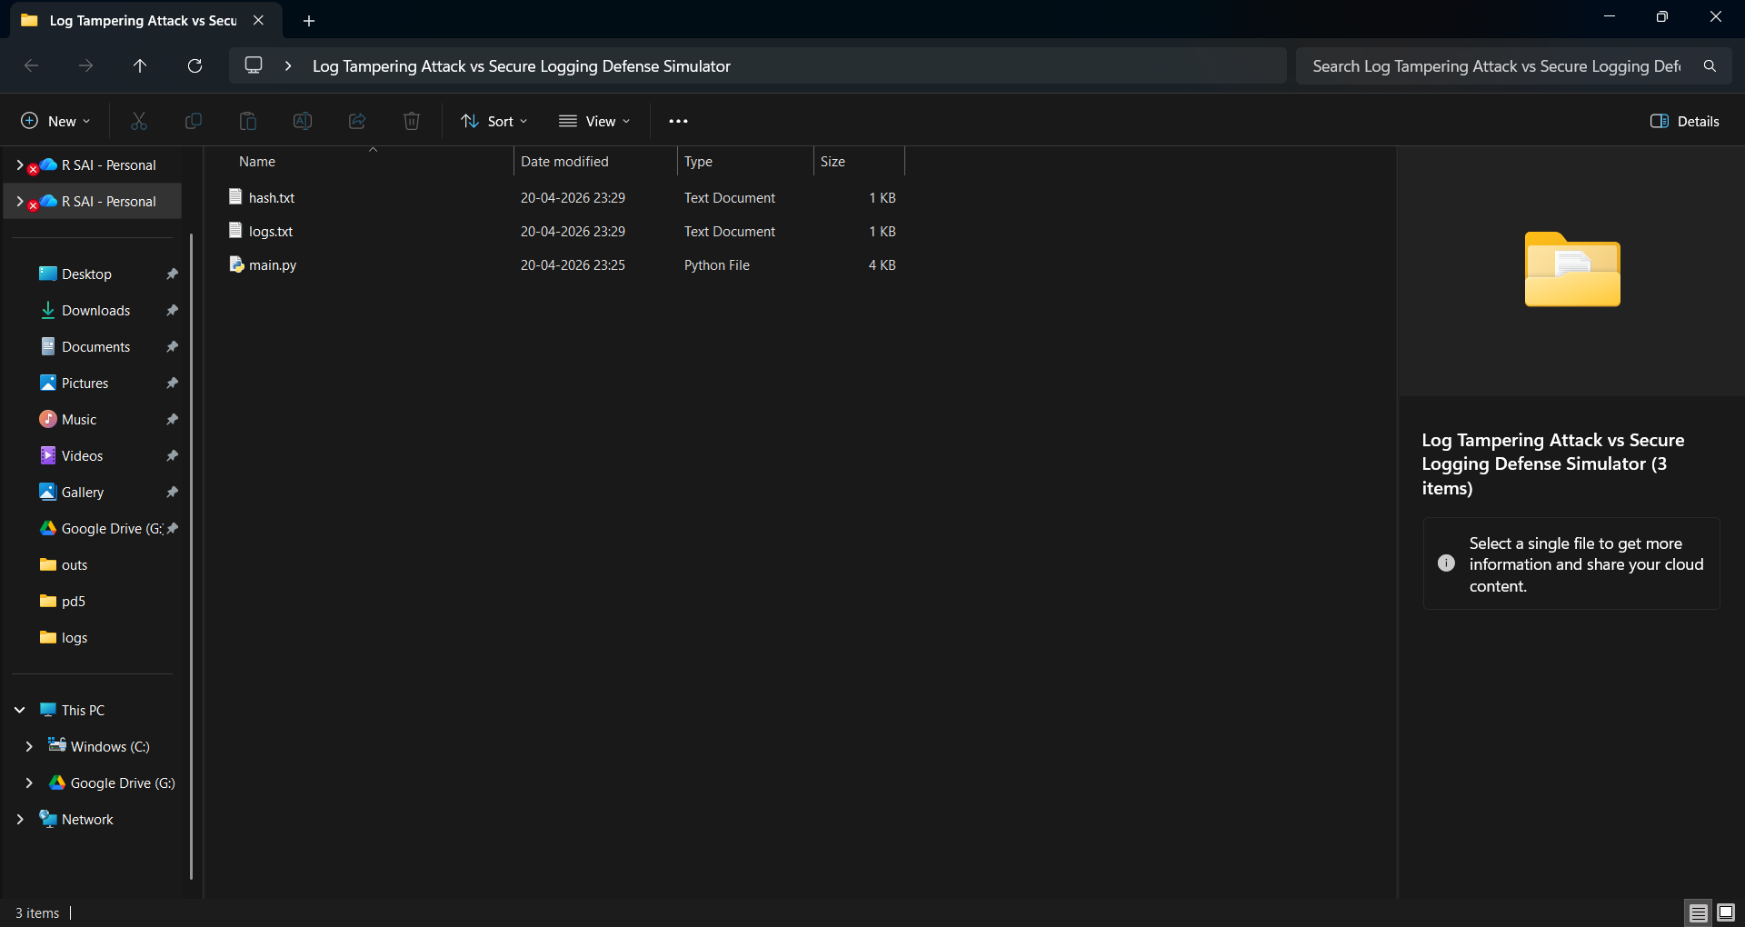



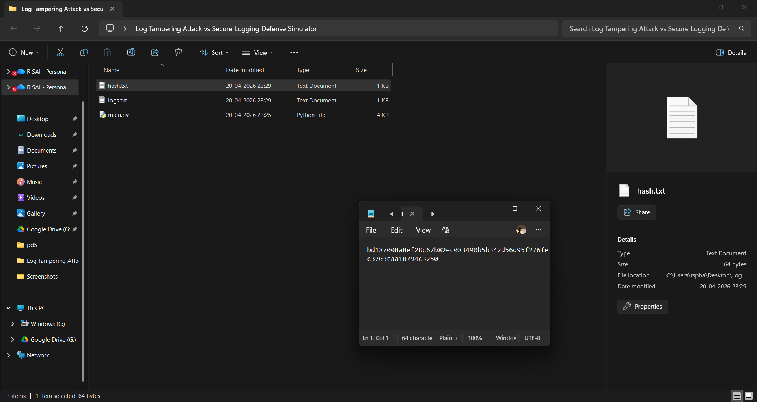

7. Implementation:
The project is implemented using Python programming language. Tkinter is used for developing the graphical user interface, while the hashlib library is used for implementing SHA-256 hashing.
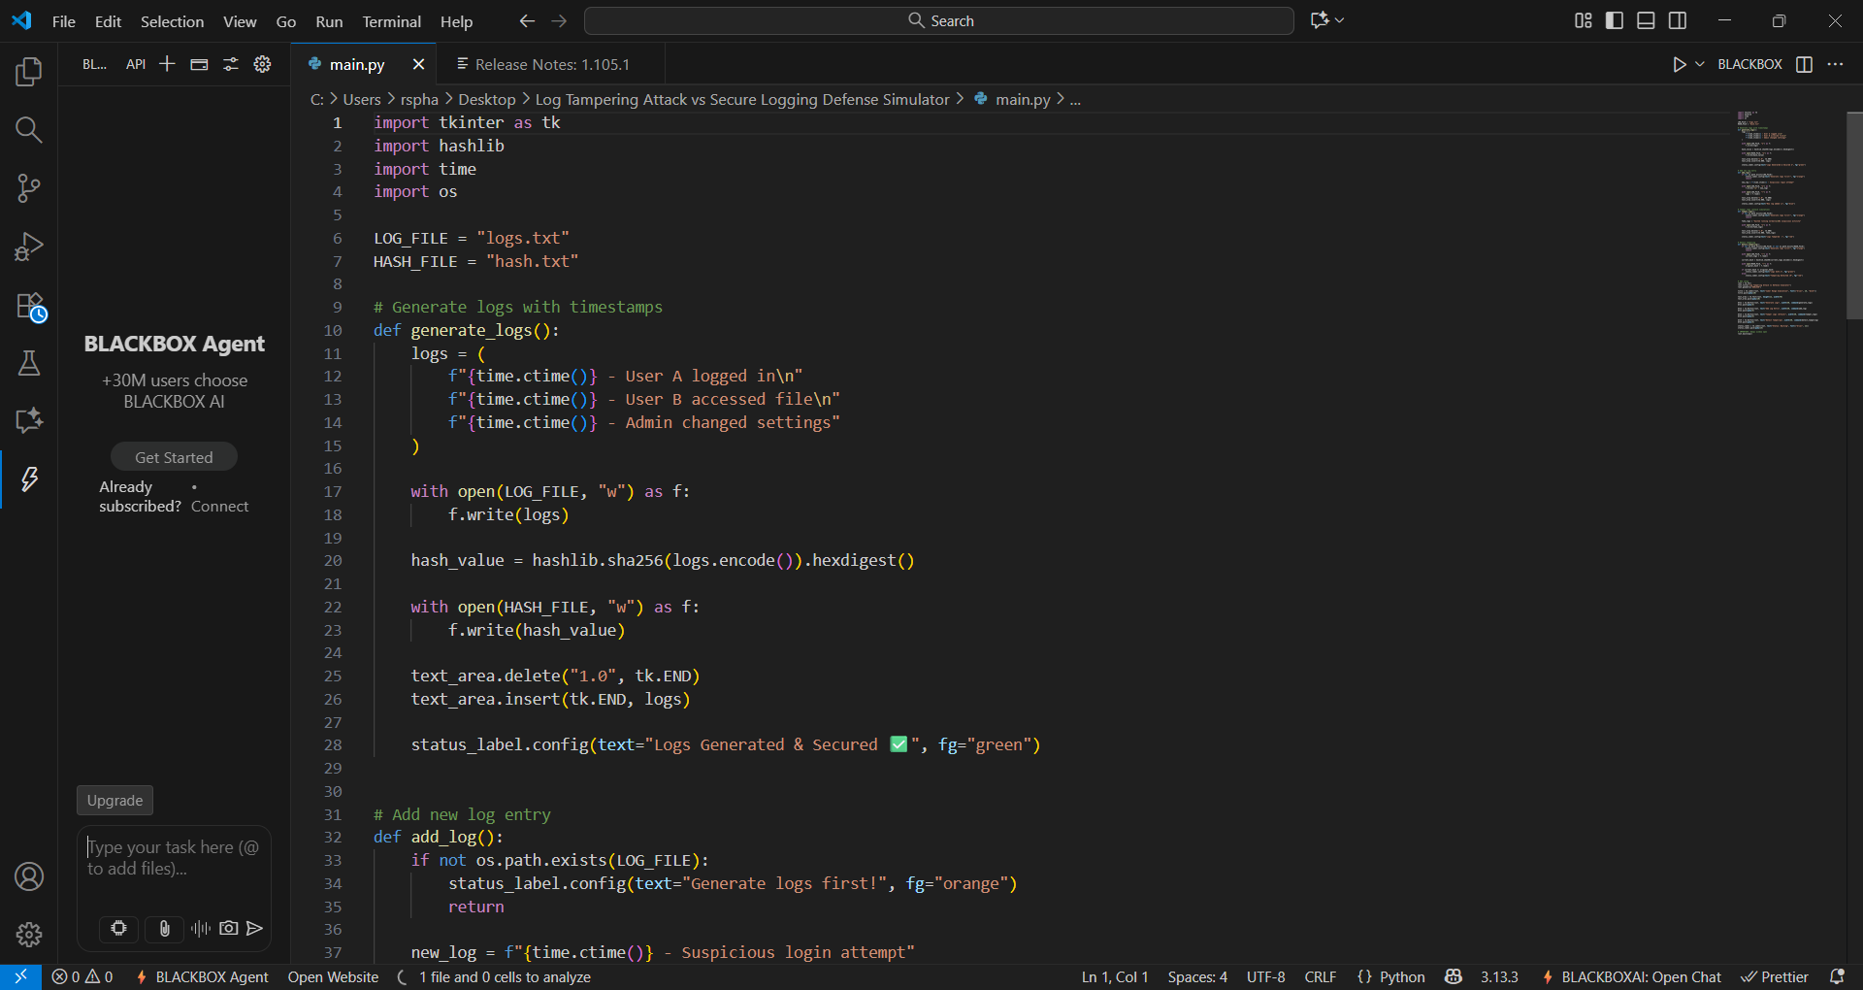

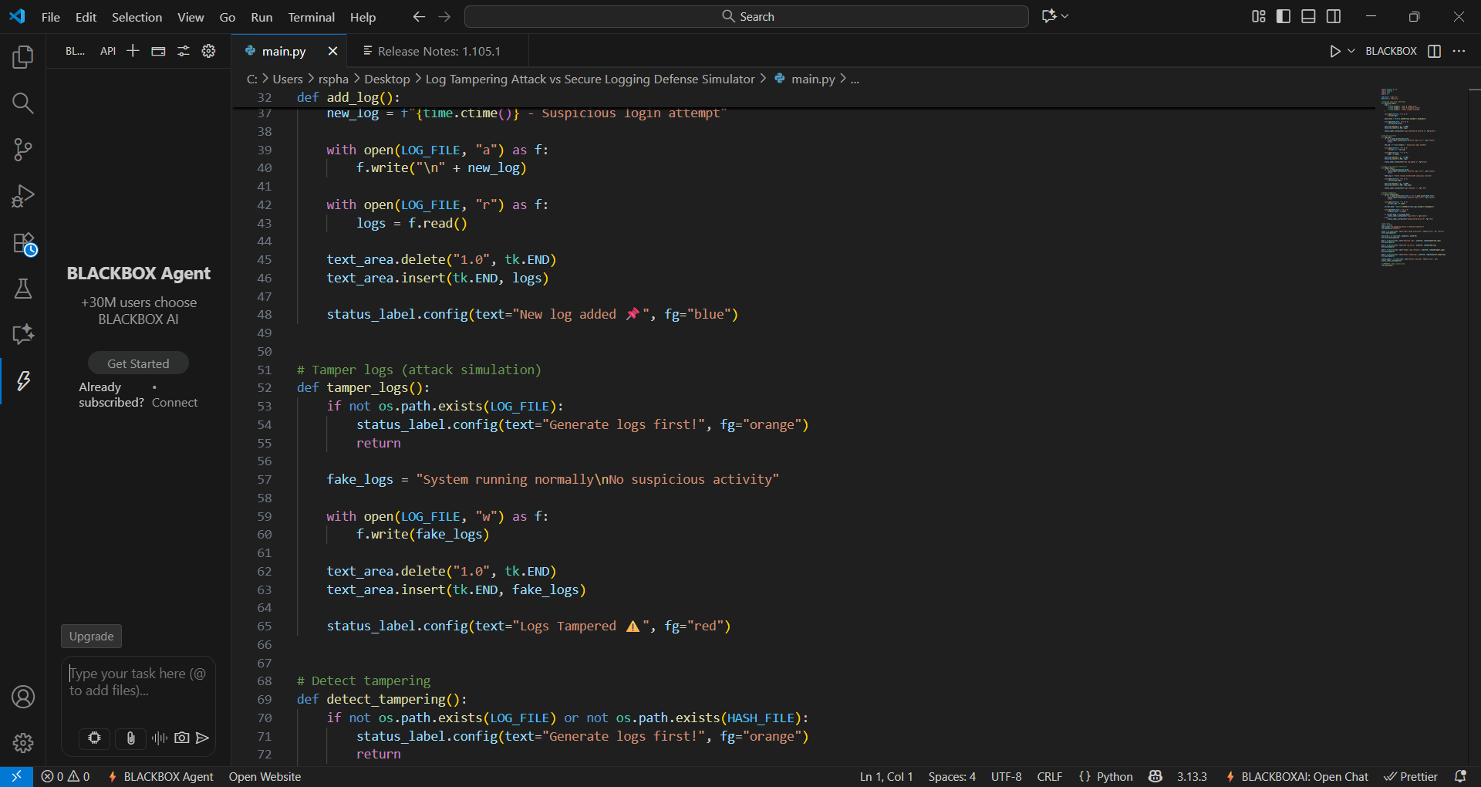
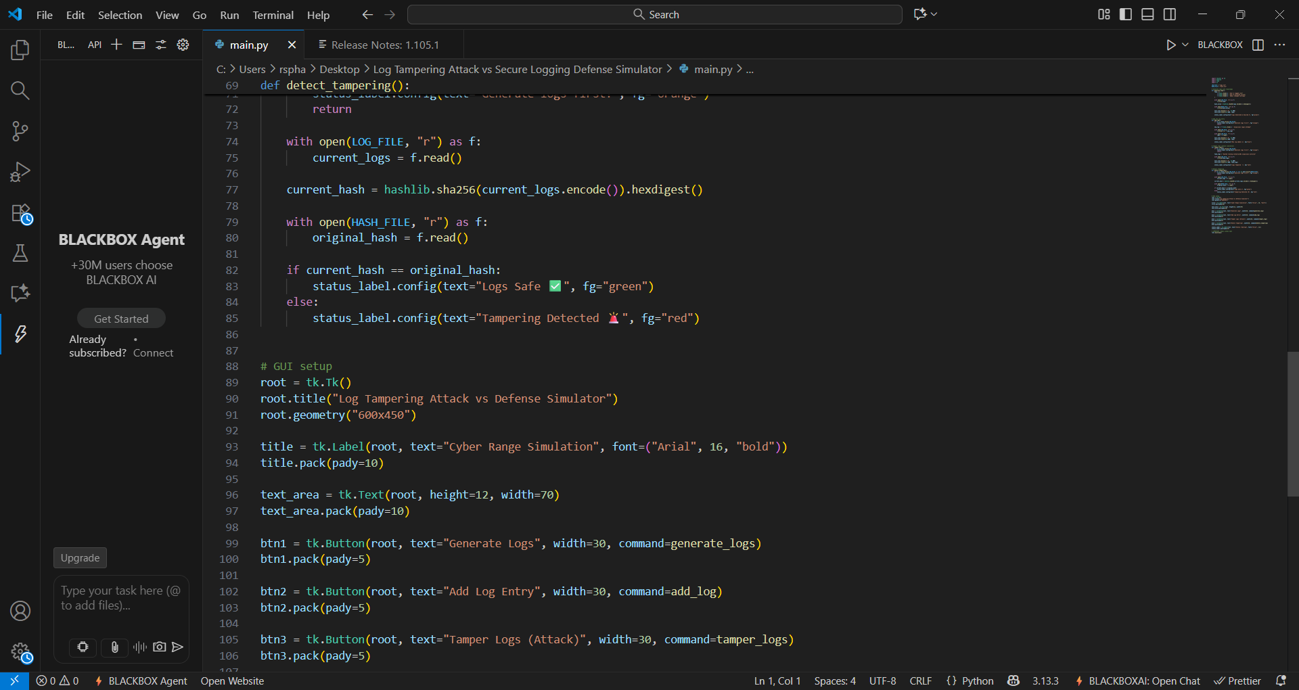
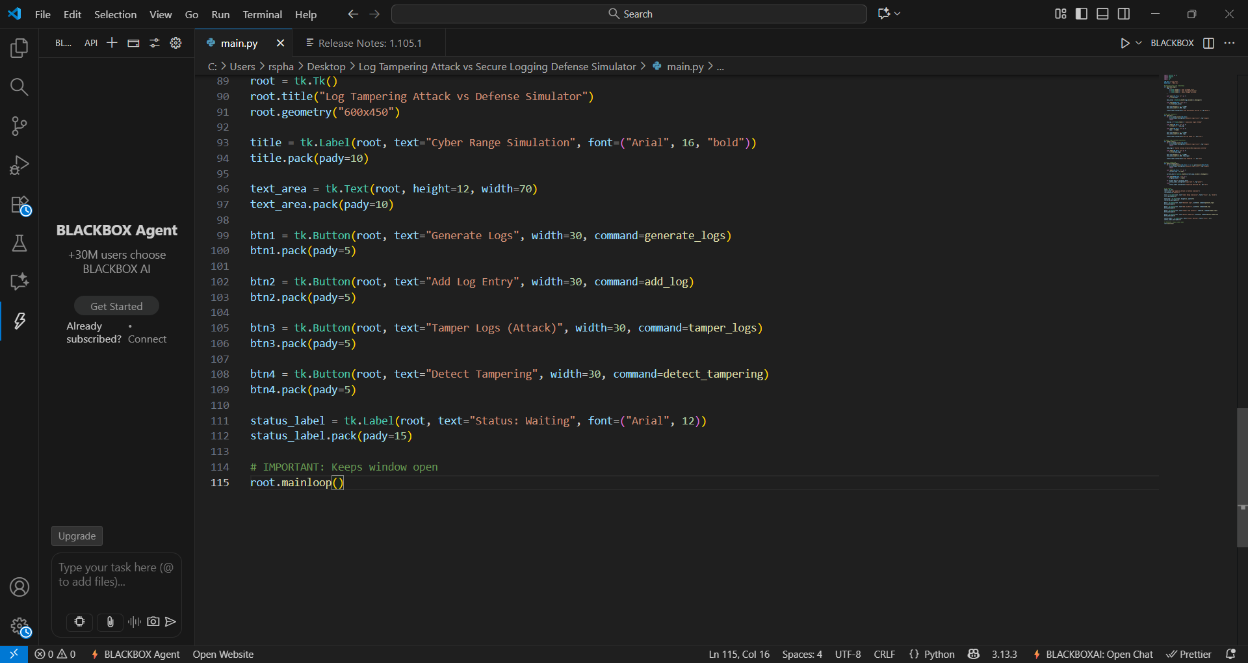
Logs are stored in a text file, and their corresponding hash values are stored separately. The GUI provides buttons for generating logs, simulating attacks, and detecting tampering.

8. Procedure:
1. Run the Python application
2. Click 'Generate Logs' to create and secure logs
3. Click 'Detect Tampering' to verify integrity
4. Click 'Tamper Logs' to simulate an attack
5. Click 'Detect Tampering' again to detect changes
6. Observe the results displayed in the GUI


9. Results and Discussion
The system successfully identifies whether logs have been tampered with. When logs remain unchanged, the system confirms their integrity. When logs are modified, the system detects discrepancies and raises an alert.
This demonstrates the effectiveness of hashing in maintaining data integrity and detecting unauthorized changes.

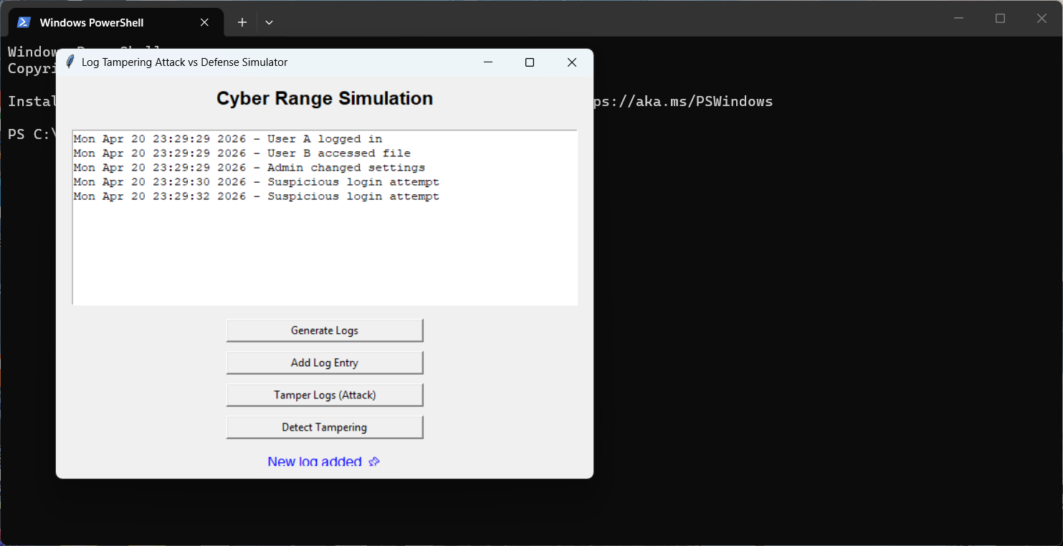
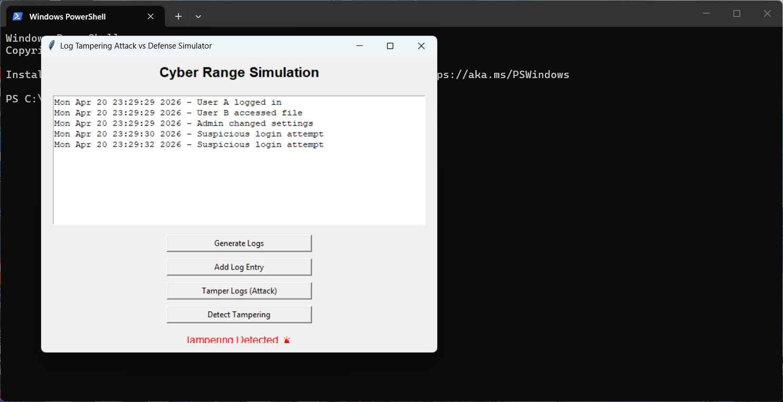

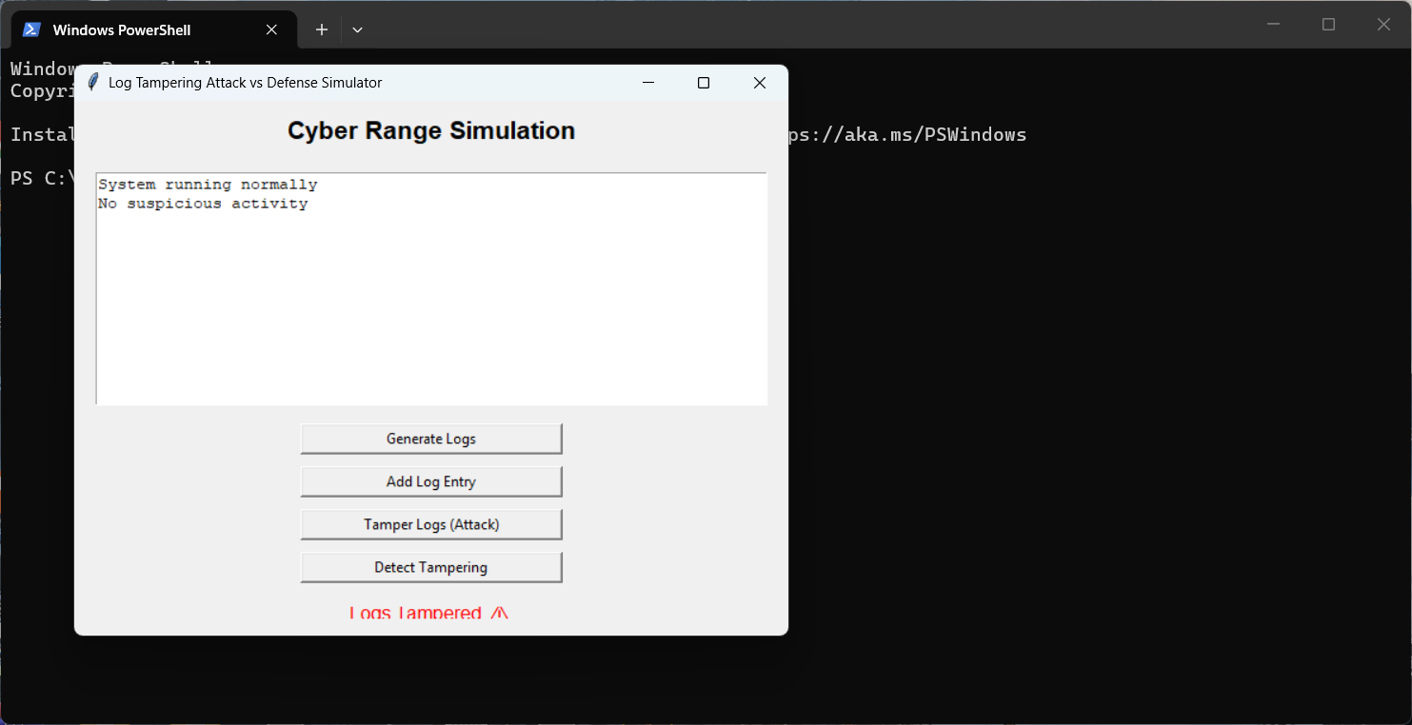
The images of the expected result such is generating alerts for tampered logs and the suspicious logs were detected.

10. Advantages:
• Simple and efficient implementation
• Demonstrates real-world cybersecurity concepts
• User-friendly graphical interface
• Easily extendable for advanced features

11. Future Scope:
• Integration with real-time monitoring systems
• Implementation of encryption for secure storage
• Integration with databases and cloud platforms
• Automated alert mechanisms (email/SMS)
• Expansion into full SIEM simulation

12. Conclusion:
This project successfully demonstrates a log tampering attack and its detection using secure hashing techniques. It highlights the importance of maintaining log integrity in cybersecurity systems and provides a foundational understanding of attack-defense mechanisms in a controlled environment.

